CCCC Disability Studies SIG
Thursday, March 22, 6:30-7:30p
America’s Convention Center,
Room 104, Level 1
We always leave time for discussion and concerns. We plan to discuss mentoring, our website and listserv, and our response to the new AAUP document on faculty accommodation. This SIG is accessible to members; send any access concerns to Amy Vidali, 303-619-0106 (phone or text).
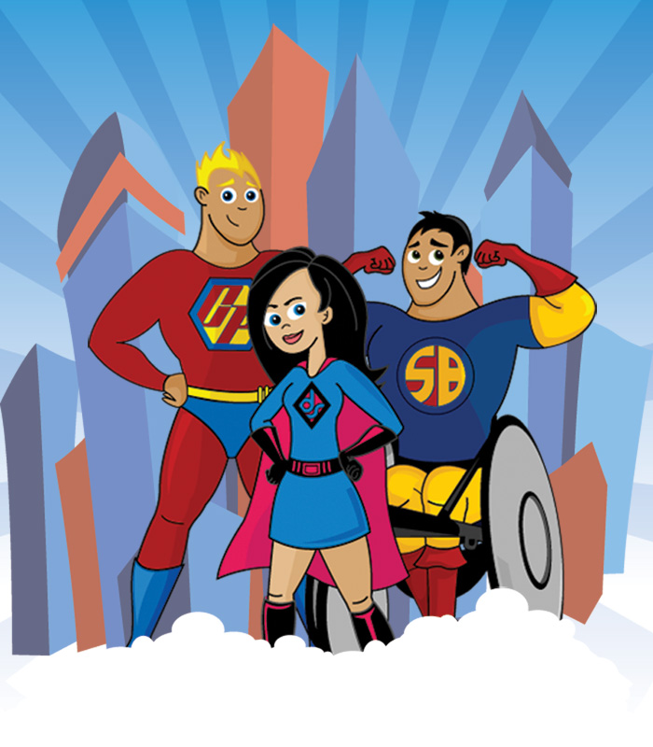
Not to be confused with super-cripples, the sharply-drawn cartoon above portrays disabled superheroes, as depicted by Kyle Boyd (www.disabilityheroes.com/blog/). The image is of three figures: a dark haired woman in a dress with “ds” on her chest, a tall blond superman-type figure with “CP” on his chest, and a dark-haired man flexing in a wheelchair, with “SB” on his chest. An abstract city rises in the background, with clouds along the bottom of the frame. Two of the three figures make eye contact with the viewer, and all smile.

